Activities related to the International Day of the Intangible Cultural Heritage in 2025
Each year, 17 October marks the International Day of the Intangible Cultural Heritage. On this occasion, stakeholders of the 2003 Convention for the Safeguarding of the Intangible Cultural Heritage are invited to share activities to be organised in the month of October 2025. These activities will be included, on an ongoing basis, on the dedicated webpage of the 2003 Convention. More information, such as about the use of the dedicated logo for the planned activities, may be found through this webpage.

Kindly submit one form per activity to ich@unesco.org.

Organiser(s)
Lead organiser
Country
Organization | Name:
Focal point 1 | Name & title:
Phone number
Email address
Focal point 2 | Name & title:
Phone number
Email address
Co-organising partners (if applicable)
Co-organizer 1 | Name:  Country:  Organization:
Co-organizer 2 | Name:  Country:  Organization:
Co-organizer 3 | Name:  Country:  Organization:

Initiative description
Title of the event
(maximum 150 characters including spaces)
…..
Type of event | ☐ Conference / Seminar / Lecture / Roundtable  ☐ Publication  ☐ Audiovisual production (film, music clip)  ☐ Exhibition  ☐ Competition (photo, video, written piece)  ☐ Festival  ☐ Educational activity  ☐ Other (please describe): ………………………
Date
Webpage (if applicable) | Link:
Modality of the event | ☐ In person  ☐ Online ☐ Hybrid
Level of activity | ☐ Local  ☐ National  ☐ Regional  ☐ International  ☐ Other (please specify): ………………………
Brief description
(Provide a short description of the event, background, objectives. Not exceeding 500 words)
……
Programme of the event (if applicable)
(Please add programme items -even if preliminary)

Film screening or book launch (if applicable)
Indicate here the type of materials being provided, if applicable link to the materials

Logos & 1 visual or photo
Please provide a minimum of one horizontal photo in .png, .jpeg, .tiff, .raw or .pdf format and of at least 72 pixels per inch (PPI), together with the signed cessation of rights form (see Annex)

Please provide the logo(s) of the organiser(s) in .png, .jpg, .tiff, .raw or .pdf format and of at least 72 pixels per inch (PPI)

☐ I agree that information provided in this form be processed by the Secretariat and included on the webpage of the 2003 Convention dedicated to the International Day of the Intangible Cultural Heritage in 2025 (https://ich.unesco.org/en/international-day-of-intangible-cultural-heritage-01363).
Signature
Date: Click or tap to enter a date.

Annex
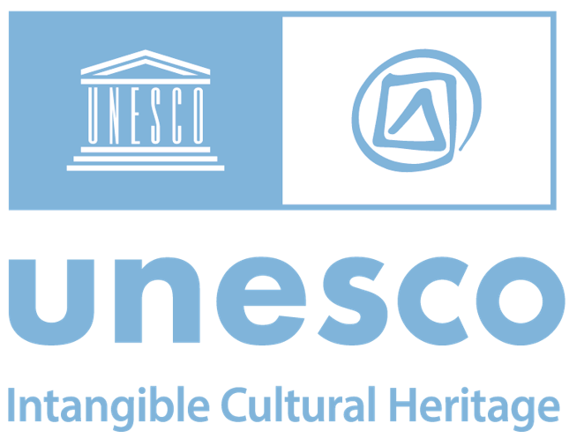 | International Day of the Intangible Cultural Heritage in 2025  Grant of Rights Form
A signed grant of rights is required for all photos submitted to accompany the activities organised on the occasion of the International Day of the Intangible Cultural Heritage in 2025. Photographs should be submitted in .png, .jpeg, .tiff, .raw or .pdf format and of at least 72 pixels per inch (PPI), together with this signed Grant of Rights Form.
- I, the undersigned, , hereby grant to UNESCO the non-exclusive rights to use, publish, reproduce, distribute, display, communicate or make available to the public, in any language or form and by any means including digital, the following material(s), in whole or in part. I grant these rights to UNESCO irrevocably, for an unlimited period of time and for the entire world.
Identifier  (for instance file name) | Brief informative caption  (no more than 40 words  in English or French) | Date | Photo Credit  (‘-----------, year’) | Photographer  (if not mentioned in the credit)

- I further grant to UNESCO the non-exclusive right to sub-license third parties to use the material(s) in whole or in part, solely for non-profit educational or public information uses.
- These rights are granted subject to the condition that the respective above-mentioned credit, or its equivalent, is provided if and when the material(s) is/are used.
- I certify that I am entitled to grant all the rights under paragraphs 1 and 2 of this agreement and that, to the best of my knowledge and belief, the material(s):
a) is/are in no way whatever a violation or an infringement of any existing copyright or licence; and
b) is/are in no way whatever a violation or an infringement of any customary practices governing access to the heritage depicted or incorporated, and contain(s) nothing obscene, libellous or defamatory.
Name: |  | Date:
Address: |  | Signature:

